Supplementary material

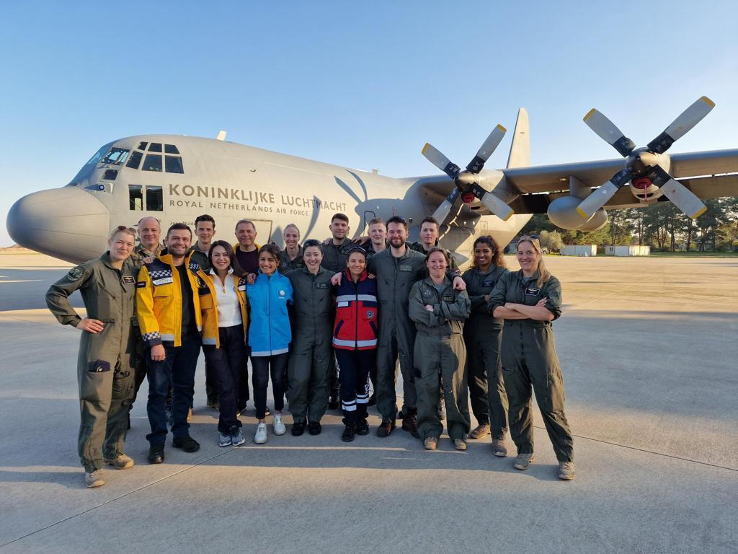
Supplementary Fig. 1. The aeromedical evacution team of 2023 Kahramanmaraş earthquake.

